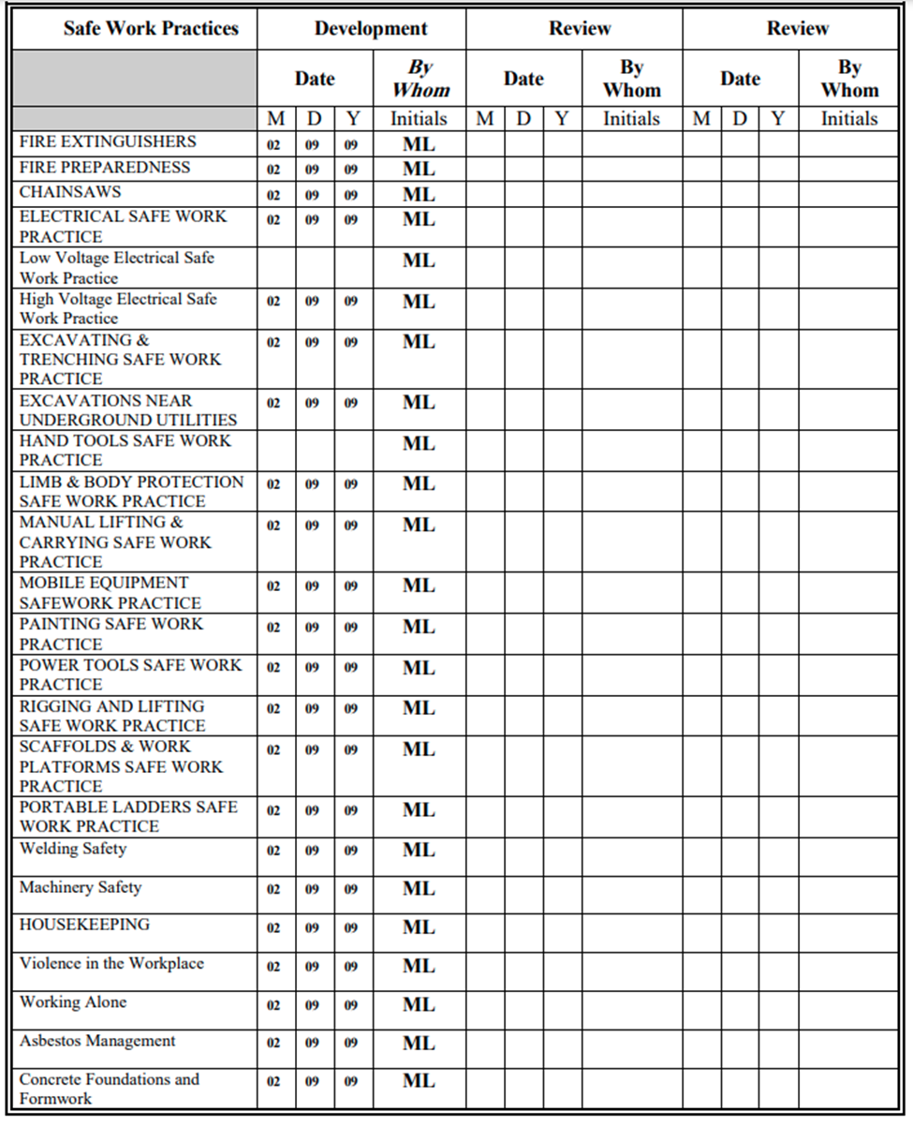
Safe Job Procedures Annual Review Form

